Mele Lāhui Hawaiʻi, Hawaiian National Anthem - Words & music by Queen Liliʻuokalani
Ka Makua mana loa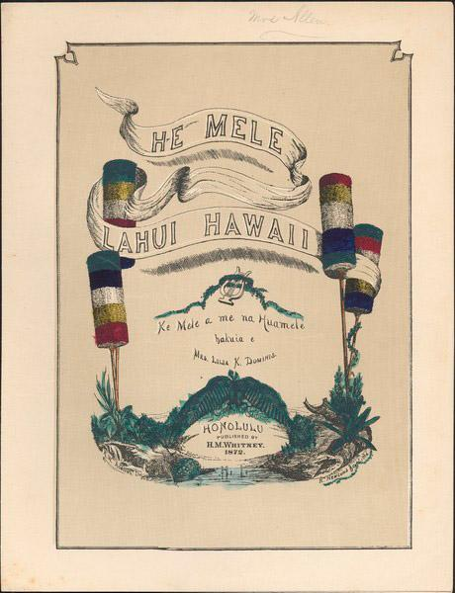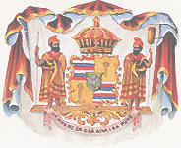
Maliu mai iā mākou
E hāliu aku nei
Me ka naʻau haʻahaʻa
E mau ka maluhia
O nei pae ʻāina
Mai Hawaiʻi a Niʻihau
Ma lalo o kou malu

Hui:
E mau ke ea o ka ʻāina
Ma kou pono mau
A ma kou mana nui
E ola e ola ka mōʻī

E ka haku mālama mai
I ko mākou nei mōʻī
E mau kona noho ʻana
Maluna o ka noho aliʻi
Hāʻawi mai i ke aloha
Maloko a kona naʻau
A ma kou ahonui
E ola e ola ka mōʻī

Hoʻoho e mau ke

Ma lalo o kou aloha nui
Na Liʻi o ke Aupuni
Me nā makaʻāinana
Ka lehulehu nō a pau
Kiaʻi mai iā lākou
Me ke aloha ahonui
E ola nō mākou
I kou mana mau
E mau ke ea
Source: - Composed November, 1866 by Queen Liliʻuokalani, at the request of Kamehameha V, this was the Hawaii National Anthem until 1967, when Hawaiʻi Ponoʻi was declared the state song. The two warriors pictured on the Coat of Arms are twin brothers, Kamanawa and Kameʻeiamoku, uncles of Kamehameha I. Copyright 1872

