Liliʻu Ē - Chant by Antone Kaoʻo, Music by John Kaulia
Ē Lilʻu ē  Noho nani mai  Kô kino ē  Kiʻi milimili  Kô maka ē  Nôweo nei  Kô papâlina  Ê kukû ana  Kô poʻohiwi  Ani peʻahi  Kô poliê  Nahenahe wale  Kô kuliê  Nuku moi ʻoe  Kô wâwae  Pahu aʻe i luna  Haʻina ʻia mai  Ana ka puana  Ē Liliʻu ē  E noho nani mai  Ē ô ē Liliʻu  I kou inoa  Ka hae kalaunu  O Hawaiʻi nei | 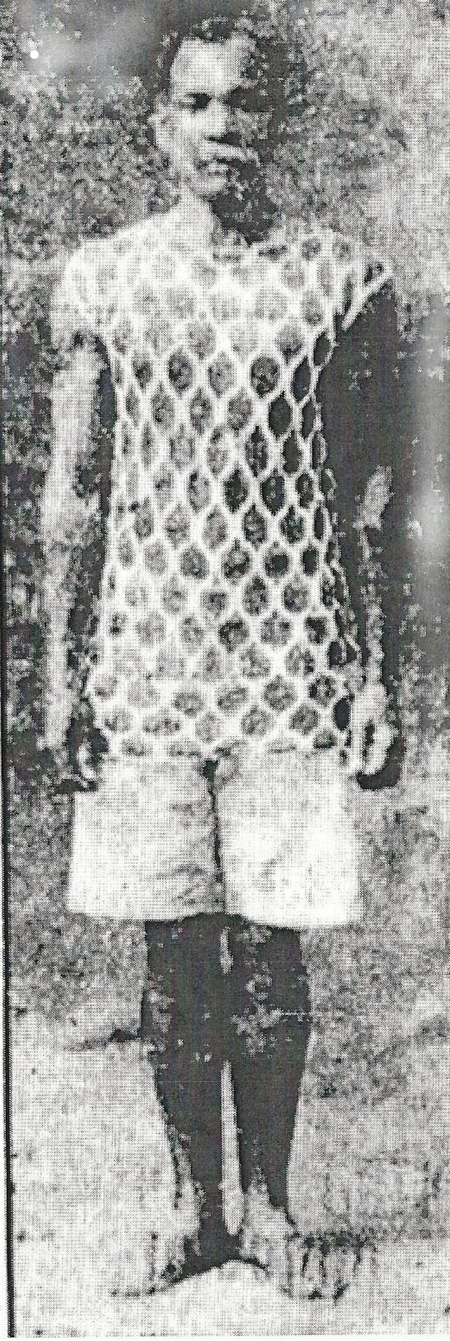  Antone Kaoʻo | O Liliʻu  Sitting so beautifully  Your person  We fondly touch|  Your eyes  Sparkle  Your cheeks  Stand out  Your shoulders  Wave like a fan  Your bosom  Is so soft  Your knees  Like a moi fish nose  Your feet  Are lifted up  Tell  The refrain  Of Liliʻu  Sitting beautifully  Answer, Liliʻu  To your name  The crowning glory  Of Hawaiʻi
Source: Thomas T Shirai Jr., Great-Great Grand Nephew of Anton Kaoʻo (noted hula master from Waialua) - This chant was originally composed for Queen Kapiʻolani (Ê Kapiʻolani ê) and modified for dedication to Queen Liliʻuokalani. Also known as the Queen's Hula, Kaoʻo wanted to express his loyalty and aloha for Queen Liliʻuokalani. Moi is the threadfish. Copyright 1923, 43 Charles E. King | 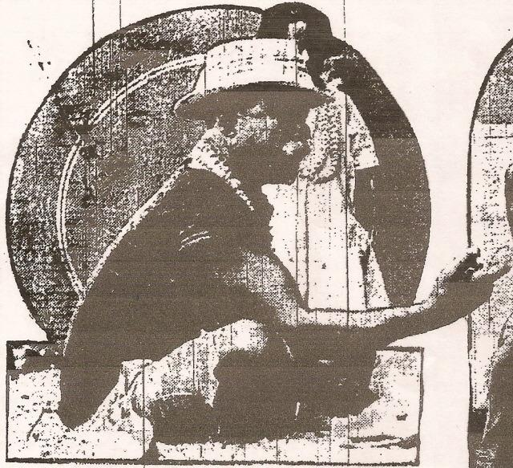  Antone Kaoʻo | 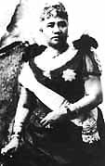  Queen Liliʻuokalani

