Käwika ( David) - J. Kealoha
Eia nō Kawika e  O ka heke aʻo nā pua  Ka uwila ma ka hikina e  Mālamalama Hawaiʻi e  Kuʻi e ka lono Pelekane e  A lohe ke kuini ʻo Palani e  Na wai e ka pua i luna e  Na Kapaʻakea he makua e  Haʻina ʻia mai ka puana e  Kalani Kāwika he inoa e | 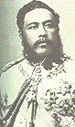  King Kāwika Kalākaua | This is David  The greatest of all flowers  (He is) the lightning in the east  That brightens Hawaiʻi|  News reached England  Also heard by the French queen  Who is this flower of high rank?  Kapaʻakea is his father  Tell the refrain  King David, is his name
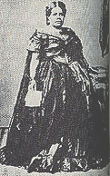  Analea Keohokalole | 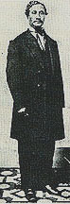  Caesar Kapa`akea | Source: King's Hawaiian Melodies Copyright 1930, 43 - This mele inoa for King David Kalākaua (1836-1891) relates how he appealed to England and France for financial aid for Hawaiʻi. He was refused. The people of Hawaiʻi are called flowers. Caesar Kapaʻakea, a great grandson of Chief Kameʻeiamoku was the father of King Kalākaua and High Chiefess, Analea Keohokalole, a counselor to King Kamehameha III, was his mother. Kalākaua ruled from 1874-1891. The sign of the Kalākaua dynasty was the noonday sun symbolized by a flaming torch at midday

