Heʻeia - music by J. Kalahiki

Aia i Heʻeia lā  I ka nalu e heʻe ana  Ea, ea, ea, ea  Heʻe ana i ka muku lā  Hoʻi ana i ka lala  Ea, ea, ea, ea  A naʻu i kīkaha lā  ʻO ia ʻae kai  Ea, ea, ea, ea  A he kuhihewa koʻu lā  Aia i ka poli  Ea, ea, ea, ea  Hāpapa hewa au lā  I ka maka o ka moena  Ea, ea, ea, ea  ʻEʻena ia manu lā  Noho mai i ke kuahiwi  Ea, ea, ea, ea  Haʻina ka puana lā  O Hālala i ka nuku manu  Ea, ea, ea, ea  Haʻina mai ka puana lā  O Kaleleonalani  Ea, ea, ea, ea | 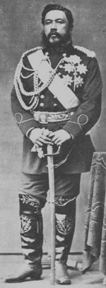  King David Kālakaua | There at Heeia  We go surfing on the waves  Tra la la la, tra la la la  Surfing of the crest  Returning on the diagonal wave  Tra la la la, tra la la la  Tis I who criss-crossed  The edge of the shore  Tra la la la, tra la la la  I mistakenly thought  You were in my arms  Tra la la la, tra la la la  I groped in vain  The meshes of the mat  Tra la la la, tra la la la  Shy was the bird  That lives in the uplands  Tra la la la, tra la la la  Tell the refrain of  The over-sized beak of the bird  Tra la la la, tra la la la  The end of my story  In honor of Kaleleonalani  Tra la la la, tra la la la
Source: Noble's Hawaiian Hulas - This chant, set to music, is a mele inoa (name song) for King Kalākaua and commemorates his visit to Heʻeia, a surfing area on the leeward side of Hawaiʻi, a favorite of aliʻi. The mele praises the surfing skill of Kalākaua and his visit to enjoy the sport and meet a sweetheart. Music clip by Lani Lee

